Features added in week 4

Area | Features Implemented | Evidence
Difficulty selection | Adds an Easy, Normal, and Hard difficulty screen before the game starts. Each difficulty changes enemy speed, detection range, tracking time, and when the enemy enters the maze. | 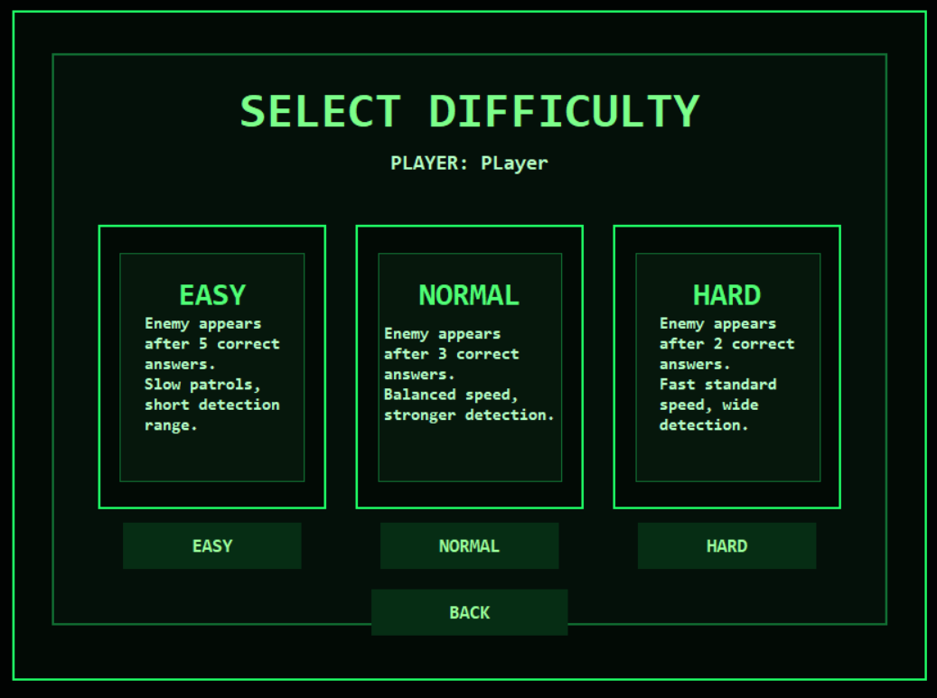
Improved enemy system | Upgrades the enemy with patrol, investigate, search, chase, final chase, and capture states. The enemy can detect the player, chase during danger moments, and use pathfinding to avoid walls. | 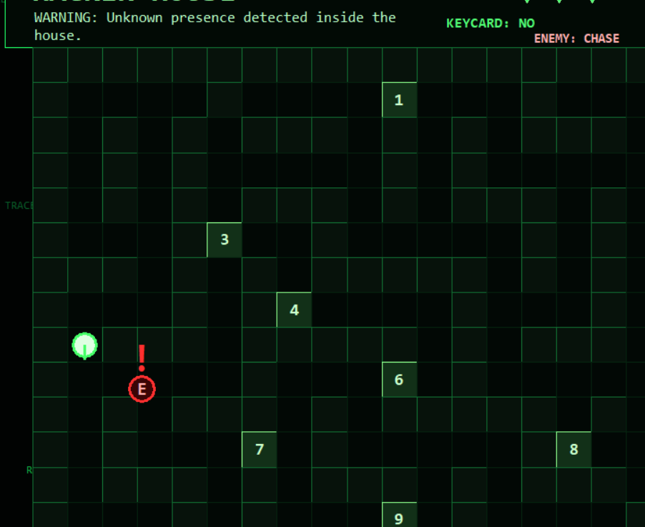  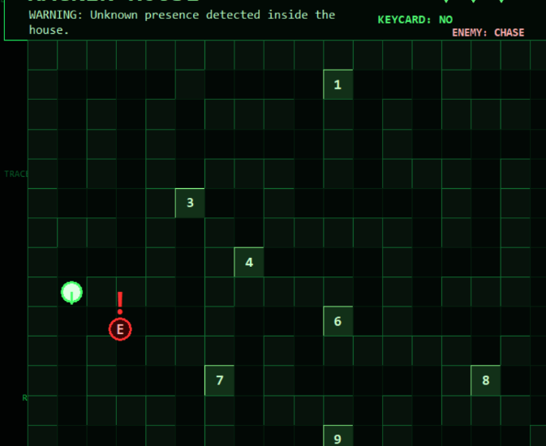  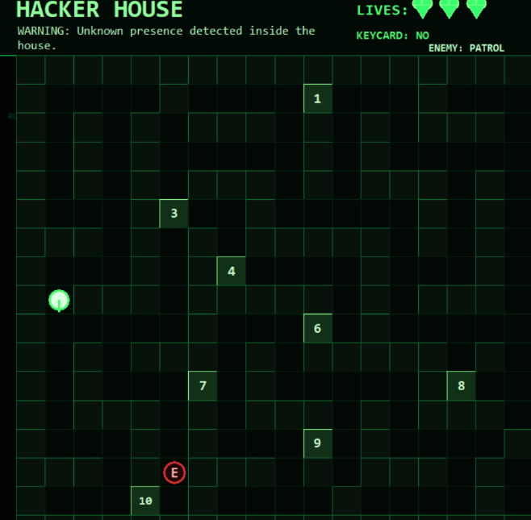  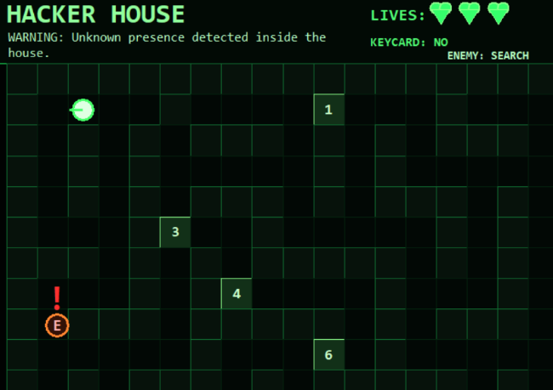
Wrong answer penalty | Keeps the door locked after a wrong answer, removes one heart, starts a 5-second cooldown, prevents repeated quiz attempts, and displays the cooldown countdown. | 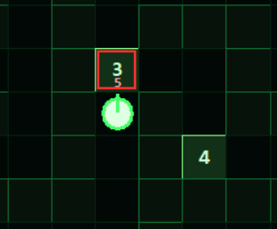
Door hacking animation | Adds an in-window hacking animation before the quiz opens, including terminal-style text, a blinking cursor, and a progress bar. | 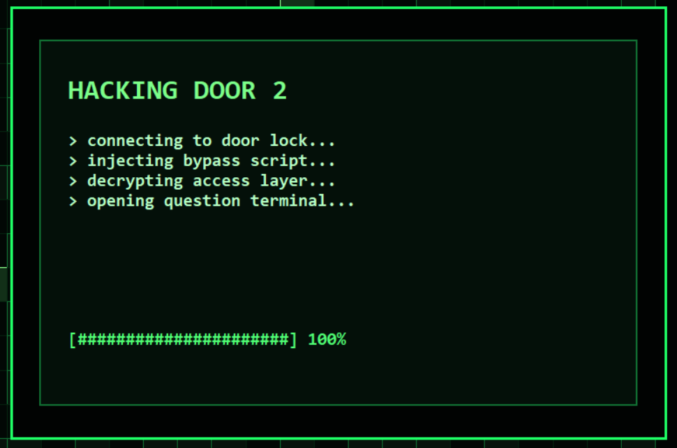
Keycard and final exit | After all doors are unlocked, a keycard appears. The player must collect it before escaping. The exit becomes active only when the keycard phase starts. | 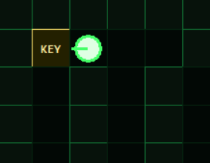
Final chase mode | Once all doors are unlocked, the enemy reaches maximum speed and continuously tracks the player until they reach the exit.
Pause menu | Adds an Escape-key pause menu with Resume, Restart Level, and Main Menu options. Restart and Main Menu include confirmation screens to prevent accidental progress loss. | 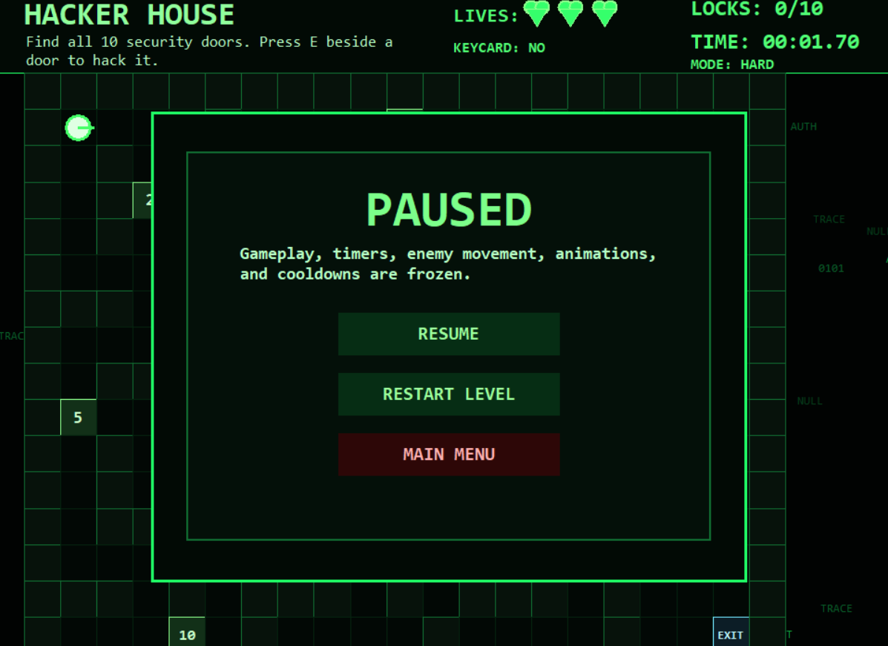
Improved maze design | Redesigns the maze with wider paths, better door spacing, alternate routes, clearer exit placement, and better enemy patrol routes. | 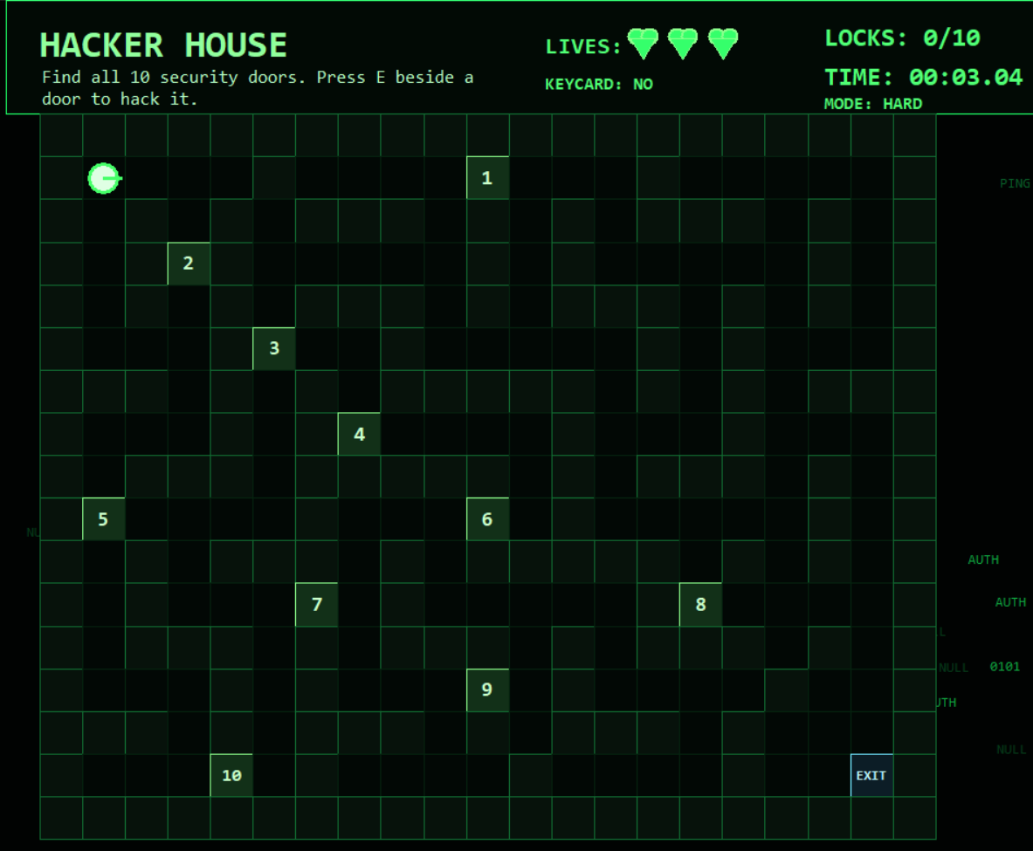
Interface and HUD | Updates the HUD to show difficulty mode, keycard status, enemy state, cooldowns, timer, locks, and lives without leaving the single game window.

